Bootstrap Z-index : **Change z-position of an element**

**Definition and Usage**

The z-index property specifies the stack order of an element.

**An element with greater stack order is always in front of an element with a lower stack order.**

**Note:** z-index only works on positioned elements (position: absolute, position: relative, position: fixed, or position: sticky) and flex items (elements that are direct children of display:flex elements).

Note: If two positioned elements overlap without a z-index specified, the element positioned last in the HTML code will be shown on top.

Example:

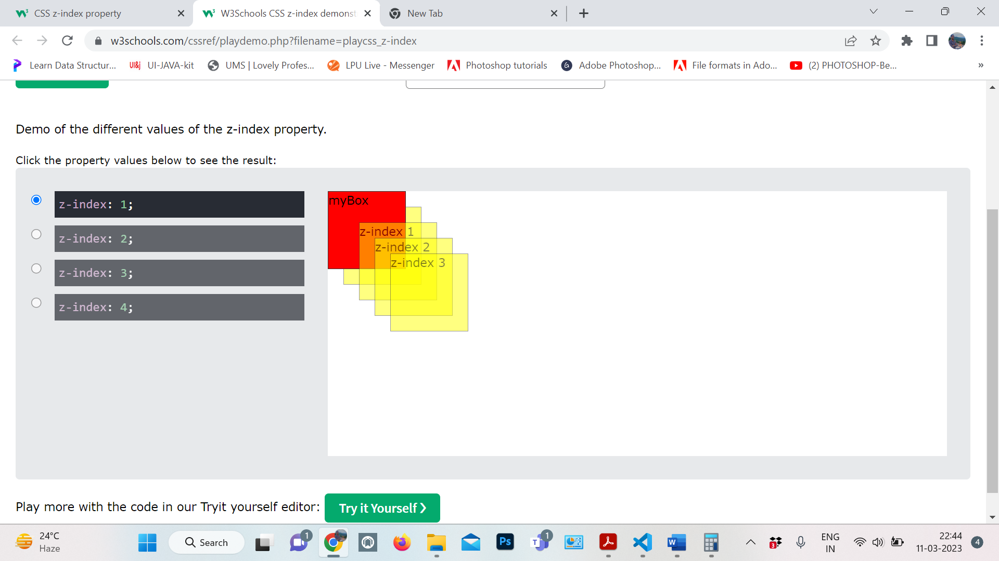

<!DOCTYPE html>

<html>

<head>

<style>

body {

background-color:#E7E9EB;

}

#myDIV {

width:100%;

position:absolute;

height:300px;

background-color:#FFFFFF;

}

#myDIV div{

width:100px;

height:100px;

position:absolute;

background-color:yellow;

border:1px solid;

opacity:0.5;

}

#myBox {

position:absolute;

background-color:red!important;

opacity:1!important;

z-index: 2;

}

</style>

</head>

<body>

<h1>The z-index property</h1>

<div id="myDIV">

<div id="myBox">myBox</div>

<div style="top:20px;left:20px;z-index:0;">z-index 0</div>

<div style="top:40px;left:40px;z-index:1;">z-index 1</div>

<div style="top:60px;left:60px;z-index:2;">z-index 2</div>

<div style="top:80px;left:80px;z-index:3;">z-index 3</div>

</div>

</body>

</html>

Z-index

Use .z-index-{n2|n1|0|1|2|master} class to change z-position of an element.

* .z-index-n2 represents z-index: -2
* .z-index-n1 represents z-index: -1
* .z-index-0 represents z-index: 0
* .z-index-1 represents z-index: 1
* .z-index-2 represents z-index: 2
* .z-index-master represents z-index: 1090 - the highest z-index